Close Reading Notes
Annotate: Taking notes while you read to help further your understanding and analysis of a text.
Types of annotations:
CROP QVS
C: Connections are the many ways you can connect your thoughts or experiences to a text.
R: Reaction is how you feel as you are reading the text.
O: Opinion of the text, topic, or idea.
P: Predict what you think will happen or has happened because of the text.
Q: Question the text. What questions do you have about what you are reading?
V: Visualize the text. What do you see?
S: Summarize the text. What is the text about in 5-7 sentences.
UNRAVVEL
Underline the title.
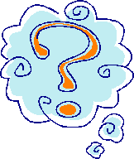
Now predict the topic and main ideas.
Run through and number the paragraphs.
Are you reading the questions?
Are the important words circled or highlighted?
Venture through the passage.
Eliminate incorrect answers.
Let the questions be answered, and write the paragraph # where you found the answers.

